**KENYAN EASIN VOLUNTEERING PROGRAMMES.**

**VOLUNTEERING IN KENYA.**

* EASIN Kenyan programs are the world’s most affordable, trusted volunteer organizations with the best experiences in the world. Volunteer work stations are available throughout the year and based in a variety of Kenyan communities such as Maasai and cities such as Nairobi, Nakuru, Mombasa, Masai Mara and surrounding rural villages. While volunteering in Kenya, the following wide ranged projects are available:

1. Teaching program in schools.
2. Childcare project.
3. Sports education.
4. Music Education.
5. Adopt a Granny (Old Age Home) project.
6. Animal Care.
7. Angaza Project (Light Project)
8. Crafts Education (Akili ni Uwezo)

**AT A GLANCE:**

1. Available year round.
2. 9 meaningful project options to choose from.
3. Projects based in and around Nairobi, Masai Mara.
4. Accommodation in friendly local hosts with the best standards.
5. Program fees inclusive of Airport pick-ups, orientation, accommodation, meals and 24hr in country support.
6. Safaris are available after project is complete. All available in welcoming letter and their charge details attached for each to choose from

**REVIEW OF PAST EXPERIENCES:**

1.Nicole Lyu.

* 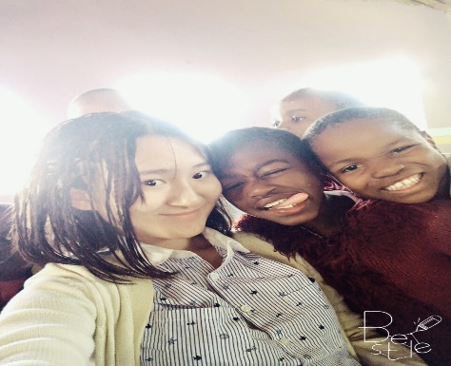She experienced her volunteer programme at the House of Mercy Children’s Home.
* She had a great time with the kids in the childcare center and made her feel like they were her own brothers and sisters in spite of them facing unfortunate situations in life and created an impact in them.

2.Zoe.

* 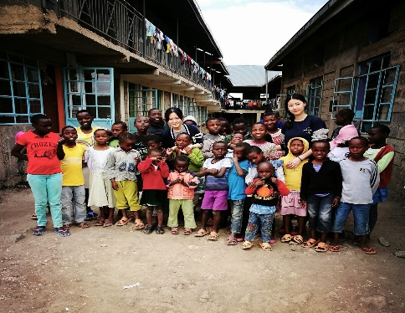She says that this kids are so young but very bright. The only difference comes in that they live together as one all having different stories of negligence and other unfortunate circumstances but we are all one.
* This was a great experience for me.

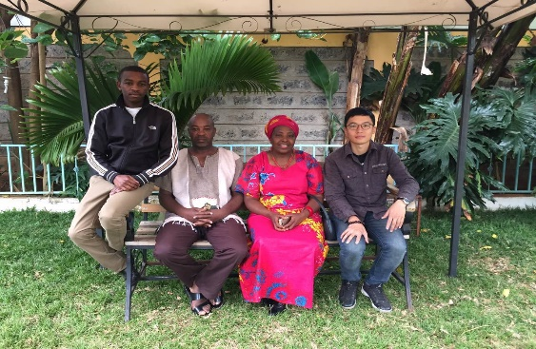3.Adam Chen

* He loved his stay and was amazed by the hospitality he had in Kenya.
* He said this host family was like his second family in a different country though no blood relation but am amazed by the care. “That’s my second home away from home.”

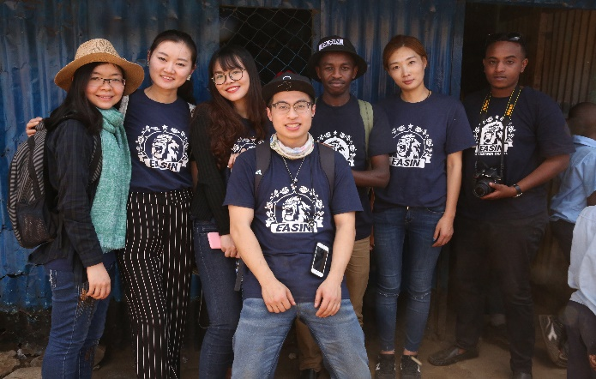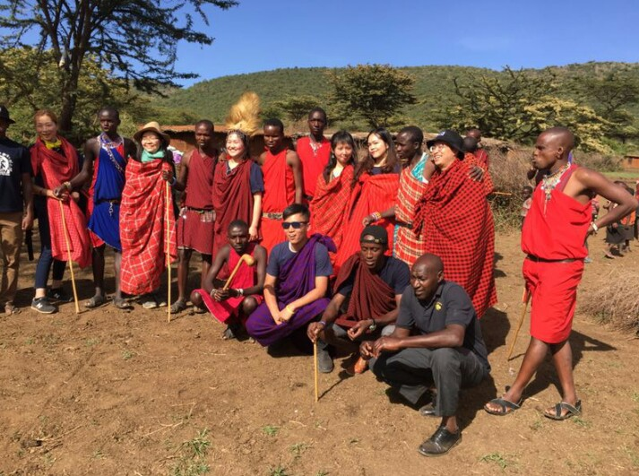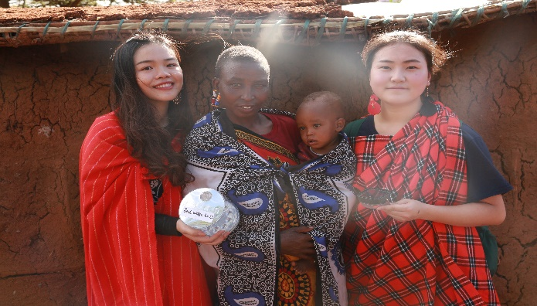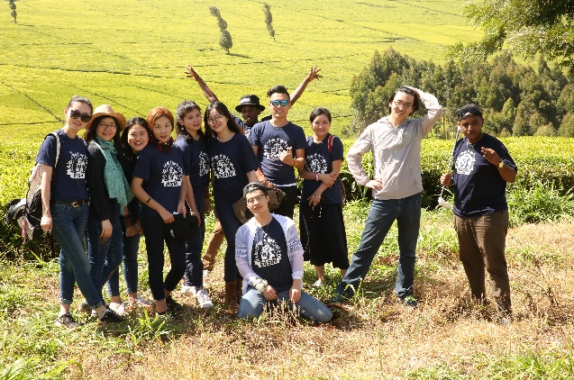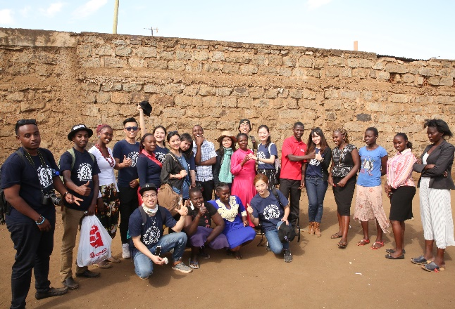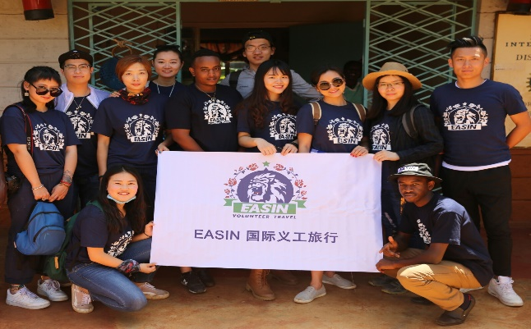4.Special Project Team

* This team enjoyed its full time Light project to the fullest. It was a very short time project but we successfully accomplished creating an impact in the short time they had for each project. Left a smile on each place they had a stop. “Where there is light there is Hope” they said and put light in rural villages where light was a story told.
* They were a total of 10 volunteers/Goers for the project having done:

School project, Old Age Home project, High school project & light project in Masai Mara.

5.Ada

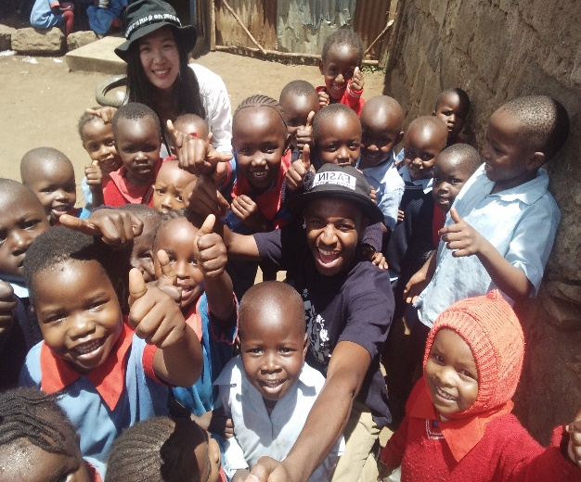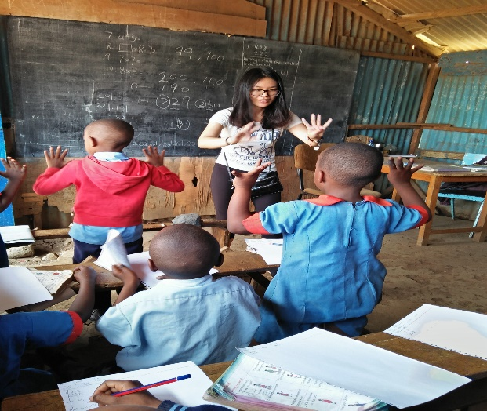

She taught some Mathematics in a class 2 classroom and they loved her mode of teaching though she didn’t believe she could teach. She loved the experience of teaching young ones that are willing to listen and learn new ideas and methods. She discovered a skill she didn’t know and now she left being the happiest volunteer with a new skill.

**WHY VOLUNTEER IN KENYA WITH EASIN?**

A question most travelers and volunteers will ask themselves and do great research to find a suitable answer. Well, Kenyan EASIN Volunteer Programme has the best answer and solution on why as:

1. Most Affordable fees –As the Kenya lead in affordable and volunteer travel, we are able to keep our fees as low by partnering with local organizations in Kenya to support meaningful community projects and local best curriculum programs.
2. New friendship - As a volunteer in the Kenya EASIN Volunteer program, you get to be interacted with s many new people in the projects to assist you in your activities and to make you feel comfortable as possible. Friends are a sign of great leadership and social impact around you.
3. Safety - Volunteer safety is a TOP priority for Kenyan Easin Volunteer Programmes and we have a clear standard for risky management on each programme you enroll in. You can feel confident that you are placed with trustworthy institutions, organizations and families that have been screened by our local teams.
4. Responsible projects - We have made sure that we have sustainable impacts that are supporting local needs and are responsibly running throughout.
5. Training and Guidance-In our projects we have taken the step first giving first-hand information to volunteers. Immediately upon arrival of a volunteer, well detailed information is provided to volunteer and how to curb any problem that may arise. So that also upon attending projects volunteer can have detailed information of what is expected of them and how to achieve that.
6. Best Experience-Ever travelled on an adventurous Tour Safari? Then I guess you are at the right choice of volunteering here. You get a chance to experience a Safari where you will get to see great number of animals in the wild as we tour the jungle in well customized vehicles for a Safari.

**LOCATION,DURATION AND AWARDS:**

* Our programs are based in Nairobi, Kenya with volunteer placements located in suburban areas of Nairobi.
* Mathare
* Kibera (Largest slum in Africa)
* Masai Mara
* Githurai 45 etc.
* Duration:

Volunteers can choose to volunteer for periods ranging from 1 week to 6 weeks during any time of the year of their choice.

* Awards:

Upon completion of project, Certificates are awarded to you for Good conduct and Active participation in projects.

**PROJECTS:**

* **MUSIC EDUCATION.**

Music is a universal language and spans all corners of the globe. On the Music project you will provide students with a basic understanding of musical theory, as well as instrument and vocal training. If you are looking to teach music that requires an instrument, we recommend bringing this with you. Previous volunteers have taught an introduction to Music class or have focused on teaching specific instruments such as guitar, flute, maraca, etc. Singing is popular among the children, and if you have experience in singing or choir-directing, this can be highly beneficial on the project. In addition, you can facilitate traditional music lessons, where students share and learn cultural and tribal songs from each other. The music project is mainly run after school and therefore you may be required to teach other classes during the day such as Math, English and Social Sciences. Please note that if you apply for the Music project during the school holidays (April, August, November and December), you will be placed on another project in Kenya, such as Childcare Work, for the duration of the holidays.

* **CHILDCARE.**

Volunteers on the Childcare project in Kenya are placed in a range of orphanages and childcare centers, some of which house and foster abandoned and orphaned children, some that have schools attached, and others where volunteers live at the centers full time. Each center accommodates children of differing ages; however, volunteers generally work with children between the ages of 1 to 16 years old. Placements can include pre-schools, baby daycare centers and orphanage centers. Whether the children are at home or at school, the centers are always busy, and volunteers can help with all areas of daily activity. Tasks can include teaching, cooking, cleaning, feeding, washing, and caring for the children, in addition to entertaining and playing with them.

* **SPORTS EDUCATION.**

The Sports Education project is designed for volunteers who have passion for sports and wish to work with children in schools, but would prefer not to spend all their time teaching in a classroom. On the Sports Education project you will help to broaden the children’s knowledge of sports, teach foreign sports, and educate the children on general fitness, health and wellbeing. While football/soccer is extremely popular in Africa, many volunteers have found it rewarding to teach the children other sports from their home countries, such as baseball, lacrosse, basketball, cricket, Ping-Pong, Tae kwondo and rugby. If you wish to teach a foreign sport, you will need to plan ahead and bring the required materials and equipment with you, as it is unlikely you will find this equipment at the local stores in Kenya. You do not need any previous teaching experience to participate on the Sports Education project, however it is important to note that you may be required to teach other classes during their project, such as Math, English, Science or Social Studies (Geography and History). Please note if you apply for the Sports Education project during the school holidays (April, August, November and December), you will be placed on another project in Kenya, such as Childcare, for the duration of the holidays.

* **TEACHING.**

On the Teaching project in Kenya you may be placed in either urban or rural schools, where the presence of volunteers is beneficial in opening the minds and broadening the horizons of students, along with exposing them to native (or fluent) English or Chinese. On this project you will be placed in community schools or government schools, and assist local teachers with daily classes in Math, English, Science, Social Studies, Art and Physical Education. There is also the opportunity for you to participate on a computer support placement. In Kenya, the school year is broken into three terms and there are breaks between these terms for the entire months of April, August, November and December. You should note that if you’ve applied for the Teaching project during the school holidays, you will be placed on another project in Kenya, such as Childcare Work, for the duration of the holidays. On this project you will work with the support of Kenya EASIN local team and placement staff and you do not need to be qualified or experienced teachers to participate.

* **OLD AGE HOME (ADOPT A GRANNY).**

At the Mji wa Huruma center we have the old category of people that have grown really old and can no longer be accommodated in their homes due to less care that can be offered to them while there but can be at best be looked after here at the Old Age Home. Here we have people of the age 70-90years.We basically offer a helping hand to the social workers on the care for all this people that require attention from them 24hrs a day. Normal chores of cleaning, dusting of their rooms puts a smile on their faces, seeing one cares for them. Some suffer from disabilities and live on wheelchairs and require to be driven to the outside environment each and every time. Daily exercise to them gives some a chance of recovery from various illnesses they suffer. Volunteering mostly at the Old Age Home doesn't take a whole day because it’s just caring and comforting the old. Mostly we take part from 10.00am to 2. 30pm.

* **ANIMAL CARE**

This is a very interesting project most volunteers like to take part in. This project is basically in comparison to your small pet back at home. It’s different though, because now the animals are different. We have the Dairy farm volunteer project and the wild animals project. At the Dairy farm, volunteers not only get to volunteer but get also to learn of the different domesticated animals and how to keep them. You get to feed them, wash them and take care of their homesteads. Many volunteers like it when it comes to feeding them because the animal becomes very friendly. For you to participate in this project you don’t need professional qualifications.

* **YOUTH MENTORSHIP PROJECT.**

Volunteers get to be introduced to high school teenagers and you get to have a one on one dialogue with them. Exchange basically potentially, viable ideas that you can engage in to mentor a young talented student in a project. It answers the question 'What is that we can do together to bring about a better tomorrow for all of us?’. It helps discuss the sustainable development goals together and how we can go around them to create an Impact. It enables volunteers to discuss what is in your country we can introduce. The direct one on one talks help you figure out various strongholds in different departments. It also helps in gaining leadership skills since you get to speak to large groups and present facts before skilled professionals on how to go about any solution. To apply for this project, you do not need a professional qualification.

* **ANGAZA (LIGHT) PROJECT.**

Light is a very essential utility that we should all enjoy fully without any inconvenience. Back in the rural villages at the Masai homesteads light is a very crucial issue. Only know of the natural light from the sun and moon at night. "WITHOUT LIGHT NO HOPE” Because where there is no light you can't have great sight. Though light is an expensive utility in Kenya, technology has come up with the use of Solar powered lights that is very cheap and affordable to sustain man on planet earth. Mostly this project is undertaken during the special project application on short term breaks by volunteers back in their homes and would like to have a short programe with a great impact. It’s very impactful for some societies here in Kenya and leaves a great mark of Hope for some communities.

* **CRAFTS EDUCATION**.

Crafts is all about creativity. Be creative in any idea on the table of colors, crayons and art paper. Children like it most when they are engaged in coloring and drawing. It’s an activity that keeps their minds in an active state of mind. If you also want them to understand clearly just engage them in a drawing. Get them paint boxes, colors, crayons and art books from the store and they will enjoy your project. Painting on the walls makes them remember you more. This is an activity that many volunteers like to engage in. The project doesn’t require professional qualifications.

**ORIENTATION:**

Orientation is carried out by our Kenyan team in Nairobi. It begins on your arrival date and covers everything you need to know for your volunteer program in Kenya. Introduction to Kenya, Kenyan Customs, Language Training Details, Rules and Expectations, Safety, Travel Opportunities in Kenya, Introduction to your project and placement. The orientation will also give you a chance to meet other volunteers. Once your orientation is complete, you will be transported to your homestay and introduced to your host family.

**VOLUNTEER SCHEDULE:**

**First Day**: On your first day of volunteering, you will be escorted to your placement by a local coordinator and introduced to the placement staff you will be working with.

**Weekdays**: A typical volunteer day would be as follows:

**8.00 AM**- Breakfast with the host family.

**9.30 AM - 2.00 PM**- Volunteers travel to their placements and meet with the placement staff. Work at the placement dependent on the project and placement that each volunteer is working at. There is usually a morning tea break and lunch break.

**3.30 PM - 5.00 PM**-Work at the placement usually ends. Volunteers are free to travel back to their homestays, go sight-seeing, or do some shopping.

**7.00 PM - 8.00 PM**- Dinner with the host family.

**N/B.**

Please note, this schedule can vary depending on the particular project the volunteer is participating on.

**ACCOMMODATION:**

Volunteers are accommodated in a host family, who have been approved by our local team in Kenya. Volunteers can expect to share a bedroom with two other volunteers, comprised of single beds and bunk beds with bedding provided. Living is comfortable has electricity, running water and western bathrooms. It is exciting to stay with a host family, providing you with a unique opportunity to learn about the Kenyan way of life, meet local people, try local food, speak the local language and engage in local customs and traditions.

**MEALS:**

Volunteers in Kenya are provided with two meals per day (breakfast and dinner), which is served at the intern house. Breakfast generally consists of chai (tea), toast, fruit and sometimes mandazi (deep fried dough).

Lunch is served at the station of project such as the teaching school, children’s home and masai mara by the project host.

Dinner usually includes traditional food, such as ugali, chapatti, mboga and irio, alongside meat and vegetables.

Bottled water is readily available in Kenya and volunteers should budget approximately US$5 per week for this (2 liters per day). If you have any special dietary requirements, please let us know when you apply for the program so we can make arrangements for you.

**REVIEW:**

“I felt like the local staff were family, even though I really did not know them! They always made sure that we were aware that we could contact them no matter what. The orientation was excellent! It was a great time to meet with other volunteers, get familiar with the staff, and start to feel at home in an unknown country! My favorite moment from the volunteering experience was spending time in my project, getting to know the kids, staff, and doing my best to help around with chores and host family that treated me as their own child. I will Miss mother Kenya for hosting me too.”-Nicole lyu (Shanghai, China)

**WEEKENDS AND TRAVELS:**

During the weekends, volunteers have free time to relax or take the opportunity to explore Nairobi, wider Kenya and Eastern Africa. Long weekends can be taken to travel on a safari.

• **Masai mara** -Great wild beast migration wonder of the world.

• **Amboseli national Park**-Best view of the Highest mountain in Africa (Mt. Kilimanjaro).

• **Mombasa Beaches**-Coastal shores of Kenya

• **Mt. Kenya snow Peaks**-Hiking activity.

• **Mt. Kilimanjaro**-Hiking

• **Lake Nakuru** -Millions of flamingo’s pink in color.

• **The Great Thompsons Falls**-Biggest water fall in Kenya.

• **Lake Bogoria** hot springs.

• **Coffee and Tea Plantations**-Major export good in Kenya.

• **Lake Naivasha**-With many hippos with a boat ride.

• **Tsavo National Park**-Elephant park.

• **David sheldrick**-Elephant orphanage.

• **Giraffe centre**-feeding of Giraffes

• **Mamba Village**-crocodile village and get to feed them too.

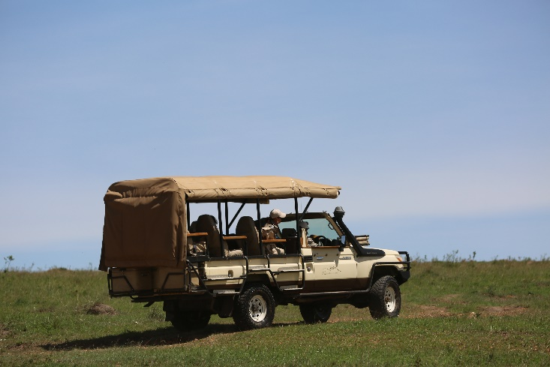 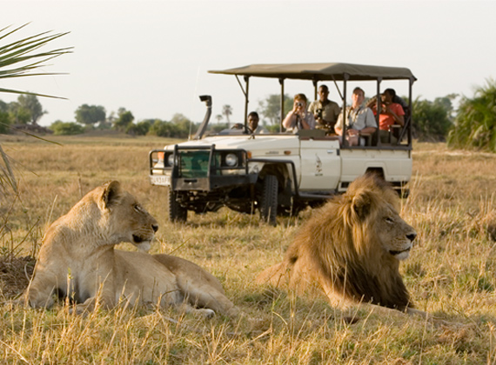

If volunteers wish to volunteer over the weekends, they can join local teams to visit orphanages and spend time playing with and entertaining the children. Sunday is a religious day of rest. If you wish, you can accompany your host family to their local church, as a Kenyan church service is a unique and special experience for many volunteers.

**N/B.** Kenyan Volunteer coordinator assists in booking this fascinating vacation safaris for volunteers if they need to travel during weekends.

**ESSENTIAL COUNTRY INFORMATION:**

Capital **Nairobi**

Population **43.18 million**

Languages **Swahili and English**

Currency **Kenyan Shilling (KES)**

Time zone **UTC+03:00**

**Weather and climate**: Kenya enjoys a tropical climate. It is hot and humid at the coast, temperate inland and very dry in the north and northeast parts of the country.

**VOLUNTEER REQUIREMENTS:**

Volunteers need to be 18 years or over to participate, unless volunteering with a parent or guardian. All volunteers are required to have adequate volunteer travel insurance and provide a criminal background check to EASIN local team on arrival in Kenya.



**KARIBU KENYA “HAKUNA MATATA”!!!**